

RAPPORT EEM: MATERIAL

Justification and selection of material



June 15, 2023

Supervised par dR PAUL KOUTEU

**Study of hull materials**

1. **Introduction**

As students, we explore the crucial choice of boat hull material. From traditional materials such as wood to modern metals and innovative composites, each option has advantages and disadvantages. We examine the characteristics, performance and applications of these materials to create durable and efficient hulls. Our goal is to provide key information to guide this crucial decision in shipbuilding.

1. **Mechanical constraints of a boat**

The mechanical stresses on the material of a mini pool boat depend on several factors, including the design of the boat, the loads applied and the conditions of use.

**1. Bending stresses:** The boat material must be able to resist bending forces when subjected to loads, such as the weight of passengers or objects on board, waves or water movement.

**2. Compressive stresses:** When the boat is in contact with hard surfaces, such as the bottom of the pool, it can experience compressive stresses. The material must be able to withstand these forces without permanently deforming.

**3. Shear stresses:** Shear forces can occur when the boat is subjected to lateral movements or frictional forces. The material must be able to withstand these stresses without warping or cracking.

**4. Torsional stresses:** When the boat is subjected to twisting movements, for example during sharp turns, the material must be able to withstand these forces without deforming or breaking.

**5. Impact stresses:** The material must be able to withstand impact forces, for example when colliding with other objects in the pool.

**6. Hydrodynamic constraints:** material must be resistant to water and chemicals present in pool water, in order to prevent corrosion or degradation of the material.

1. **Criteria for selecting the hull material of a racing boat**

When choosing materials for the hull of a racing boat, it is essential to take into account several important criteria. Here are some of the main selection criteria:

**1. Rigidity and strength:** The hull of the boat must be sufficiently rigid to withstand the forces exerted on the vessel during racing, as well as possible impacts with waves or other obstacles. Materials such as carbon fiber or fiberglass composites can provide excellent strength while remaining lightweight. The properties to study here are;

* Young’s modulus
* Vicker hardness
* Resilience

**2. Lightweight:** Reducing hull weight is essential to increasing boat speed and performance. Composite materials, such as carbon fibers, are often used due to their light weight and high strength.

* Density

**3. Durability:** Racing boats are subjected to extreme conditions, such as UV rays, salt water and high mechanical stress. It is therefore important to choose materials that resist these factors well, such as corrosion-resistant composites or special alloys.

**5. Cost:** The cost of materials is an important factor to consider. High-end materials, such as carbon fiber, may be more expensive, while other cheaper options, such as glass-fiber reinforced polyester, may also be used.

1. **Families of materials commonly used for boat hull**

* **Metals**

- Metals are elements that have high electrical and thermal conductivity, lustre, and malleability.

- Metals can be classified into different groups based on their physical and chemical properties, such as alkali metals, alkaline earth metals, transition metals, etc.

- Metals have various applications in different industries, such as construction, transportation, electronics, medicine.

* **Wood**

Wood is a natural, organic material derived from the stems, branches, and roots of trees. It is one of the most widely used and versatile materials in the world. Here's a description of wood:

**1. Composition:** Wood is primarily composed of cellulose fibres, hemicellulose, and lignin. Cellulose provides strength and rigidity, hemicellulose acts as a bonding agent, and lignin provides structural support. Wood also contains small amounts of extractives, resins, and other organic compounds.

**2. Natural Beauty:** Wood is known for its natural beauty and aesthetic appeal. It exhibits unique grain patterns, colours, and textures that vary depending on the tree species and growth conditions. This natural beauty makes wood a popular choice for furniture, flooring, and decorative applications.

**3. Strength and Durability:** Wood is a strong and durable material. Different wood species have varying levels of strength and hardness. Hardwoods, such as oak or maple, are generally denser and harder than softwoods, such as pine or cedar. Wood's strength and durability make it suitable for structural applications in construction and engineering.

**4. Workability:** Wood is highly workable, meaning it can be easily shaped, cut, and joined using common woodworking tools and techniques. It can be sawn, planed, drilled, carved, and sanded to create intricate designs and structures. Wood's workability allows for customization and craftsmanship in various woodworking projects.

**5. Insulation Properties:** Wood has natural insulation properties, providing thermal and acoustic insulation. It has low thermal conductivity, meaning it can help regulate temperature and reduce heat transfer. Wood also absorbs sound waves, making it useful for noise reduction in buildings.

**6. Sustainability:** Wood is considered a renewable and sustainable material when sourced responsibly. Trees can be harvested and replanted, ensuring a continuous supply of wood. Proper forest management practices and certifications, such as Forest Stewardship Council (FSC) certification, promote sustainable forestry and responsible wood sourcing.

**7. Environmental Impact:** Wood has a relatively low carbon footprint compared to other building materials like concrete or steel. It stores carbon dioxide during the tree's growth, helping to mitigate climate change. Additionally, wood is biodegradable and can be recycled or repurposed at the end of its life cycle.

**8. Vulnerability to Environmental Factors:** Wood is susceptible to moisture, rot, and insect damage if not properly treated or maintained. It can expand or contract with changes in humidity, leading to warping or cracking. Proper finishing, sealing, and periodic maintenance are necessary to protect wood from environmental degradation.

Wood is used in a wide range of applications, including construction, furniture, flooring, cabinetry, paper production, and artistic crafts. Its natural properties, versatility, and aesthetic appeal make it a valuable and widely utilized material.

* **Thermoplastics**

Thermoplastics are a class of polymers that are characterized by their ability to be repeatedly melted and solidified without undergoing significant chemical changes. They are widely used in various industries due to their versatility, ease of processing, and wide range of desirable properties.

**1. Molecular Structure**: Thermoplastics are composed of long polymer chains that are held together by weak intermolecular forces. These chains can slide past each other when heated, allowing the material to be melted and reshaped. When cooled, the intermolecular forces reestablish, causing the material to solidify.

**2. Reversible Process:** One of the key characteristics of thermoplastics is their ability to undergo a reversible phase transition from solid to liquid and back to solid. This property enables them to be moulded, extruded, or formed into various shapes multiple times without undergoing significant degradation.

**3. Wide Range of Properties:** Thermoplastics exhibit a wide range of properties, which can be tailored by adjusting the polymer composition and structure. Some common properties include:

**- High strength and stiffness**

**- Good impact resistance**

**- Excellent chemical resistance to various substances**

**- Electrical insulation properties**

**- Transparency or opacity, depending on the specific type**

**- Thermal stability over a broad temperature range**

**4. Processing Methods:** Thermoplastics can be processed using various techniques, including **injection moulding, extrusion, blow moulding, thermoforming, and 3D printing**. These methods allow for the efficient and cost-effective production of complex shapes and parts.

**5. Recycling and Sustainability**: Thermoplastics are considered more environmentally friendly compared to thermosetting plastics because they can be melted and reprocessed multiple times. This property enables recycling and reusing of thermoplastic materials, reducing waste and promoting sustainability.

**6. Common Types**: There are numerous types of thermoplastics available, each with its own specific properties and applications. Some commonly used thermoplastics include ***polyethylene (PE), polypropylene (PP), polyvinyl chloride (PVC), polystyrene (PS), acrylonitrile butadiene styrene (ABS), polyethylene terephthalate (PET), and polyamide (PA) or nylon.***

Thermoplastics find applications in various industries, including automotive, packaging, construction, electronics, consumer goods, and medical devices. Their versatility, processability, and desirable properties make them a popular choice for a wide range of applications.

* **Composite materials**

A composite refers to an engineered material that is made by combining two or more distinct constituents to create a new material with improved properties. The constituents of a composite material can be broadly categorized into two main components:

**1. Reinforcement:** The reinforcement component provides the composite material with enhanced strength, stiffness, and other mechanical properties. Reinforcements are typically in the form of fibres, particles, or flakes. Common types of reinforcement materials include:

* **Fiber Reinforcements:** These can be in the form of continuous fibres (e.g., carbon fibres, glass fibres, aramid fibres) or discontinuous fibres (e.g., chopped fibres, short fibres). Fiber reinforcements are known for their high strength and stiffness, and they are often used to enhance the mechanical properties of composites.
* **Particle Reinforcements:** These are typically in the form of particles or fillers (e.g., silica, alumina, carbon black). Particle reinforcements can improve properties such as hardness, wear resistance, and thermal conductivity in composite materials.

**2. Matrix:** The matrix component of a composite material acts as a binder, holding the reinforcement together and transferring loads between the reinforcement elements. The matrix material can be a polymer, metal, ceramic, or a combination of these. The matrix material provides cohesion, protects the reinforcement from environmental factors, and helps to distribute loads evenly within the composite. Common matrix materials include:

* **Polymer Matrix:** Polymer matrices, such as epoxy, polyester, or thermoplastics like polypropylene or polyamide, are widely used in composite materials. They offer good adhesion to the reinforcement, high toughness, and ease of processing.
* **Metal Matrix:** Metal matrices, such as aluminium or titanium alloys, are used in metal matrix composites (MMCs). These composites combine the strength and stiffness of the reinforcement with the ductility and thermal conductivity of the metal matrix.
* **Ceramic Matrix:** Ceramic matrices, such as silicon carbide or alumina, are used in ceramic matrix composites (CMCs). These composites offer high-temperature resistance, excellent hardness, and wear resistance.

***The combination of the reinforcement and matrix materials in a composite material creates a synergistic effect, resulting in a material with improved properties compared to the individual constituents alone. The specific types and proportions of the reinforcement and matrix materials can be tailored to meet the desired performance requirements for various applications.***

* **Synthetic fibre**

**-** Synthetic fibres are man-made materials that are derived from natural or synthetic sources.

- Synthetic fibres have many advantages over natural fibres, such as higher strength, durability, elasticity, resistance to abrasion, moisture, and chemicals.

- Synthetic fibres are widely used in various industries, such as textiles, clothing, carpets, ropes, filters, medical devices, and composite materials.

**List of materials to study**

1. Aluminium, 6061, T451
2. PARA (60% glass fiber)
3. Kevlar 29 aramid fiber
4. Iroko l
5. Okoume

**1. Aluminium 6061 T451:**

- Characteristics: It is a heat-treatable aluminium alloy with good strength, formability, and machinability. Extracted from bauxite

- Advantages: High strength-to-weight ratio, excellent corrosion resistance, and good weldability.

- Disadvantages: Can be more expensive compared to other aluminium alloys.

**2. PARA (60% glass fibre):**

- Characteristics: PARA (Polyamide Reinforced with Glass Fiber) is a composite material that combines polyamide (nylon) with glass fibres for enhanced strength and stiffness.

- Advantages: High strength, stiffness, and impact resistance. It is also lightweight.

- Disadvantages: It may have reduced resistance to heat and chemicals compared to some other materials.

**3. Kevlar 29 aramid fibre:**

- Characteristics: Kevlar 29 is a high-strength synthetic fibre known for its exceptional tensile strength and resistance to impact.

- Advantages: Very high strength-to-weight ratio, excellent resistance to impact and abrasion, and low electrical conductivity.

- Disadvantages: It can degrade when exposed to UV radiation and can be expensive.

**4. Iroko:**

- Characteristics: Iroko is a hardwood species known for its durability, stability, and attractive appearance. It has a medium to dark brown color with interlocking grain patterns.

- Advantages: Iroko is highly resistant to rot, decay, and insect damage, making it suitable for outdoor applications such as decking and boat building. It is also dimensionally stable, meaning it is less prone to warping or shrinking.

- Disadvantages: Iroko can be difficult to work with due to its high density, which can make cutting and machining more challenging. It may require pre-drilling for screws and nails. Additionally, Iroko has a high oil content, which can cause staining or bleeding when in contact with certain metals or finishes.

**5. Okoume:**

- Characteristics: Okoume is a lightweight African hardwood with a pale pink to light brown colour. It has a straight grain and a uniform texture.

- Advantages: Okoume is highly regarded for its excellent strength-to-weight ratio, making it a popular choice for lightweight construction projects such as boat building and aircraft interiors. It is also relatively easy to work with, as it has good machining and finishing properties.

- Disadvantages: Okoume is not as durable as some other hardwoods and can be susceptible to rot and insect attack if not properly protected. It may require regular maintenance and protective coatings when used in outdoor applications. Additionally, okoume is not as readily available as some other hardwood species, which can affect its cost and availability in certain regions.

1. **Technical sheets of some key’s materials**

* **Aluminium, 6061, T451**

|  |  |
| --- | --- |
| **Properties** | **Values** |
| Young modulus | 66.6-70 GPa |
| Specific stiffness | 24.5-25.8 MN.m/kg |
| Yield strength | 110-128 MPa |
| Tensile strength | 193- 225 MPa |
| Elongation | 16.7-24 % strain |
| Specific strengths | 40.5-47.2kN.m/kg |
| Compressive strength | 110-129 MPa |
| Hardness-vickers | 70-76 HV |
| Toughness | 13.3-18.9 KJ/m^2 |
| Density | 2.69e3-2.73e3 kg/m^3 |
| Price | 1.9-2.21EUR/kg |
| Poisson ratio | 0.325-0.335 |
| Durability | Fresh Water (excellent), Salt (acceptable)  UV radiation (excellent) |
| Corrosion resistance | Sligthly susceptible in chloride |
| Recycling and end of life | Recyclable |
| CO2 footprint (roll forming ,forging CO2) | 0.247-0.273 kg/kg |

* **PARA (60% glass fiber**)

|  |  |
| --- | --- |
| **Properties** | **Values** |
| Young modulus | 20.5-25.5 GPa |
| Specific stiffness | 11.4-14.3 MN.m/kg |
| Yield strength | 223-278 MPa |
| Tensile strength | 225- 275 MPa |
| Elongation | 1.64-2.36 % strain |
| Specific strengths | 125-155 kN.m/kg |
| Compressive strength | 285-315 MPa |
| Hardness-vickers | 71-80 HV |
| Toughness | 1.39-1.85 KJ/m^2 |
| Impact strength, unnotched 230C | 45.7-67.2 KJ/m^2 |
| Density | 1.77e3-1.81e3 kg/m^3 |
| Price | 3.7-3.84 EUR/kg |
| Poisson ratio | 0.324-0.326 |
| Durability | Fresh Water (excellent), Salt (acceptable)  UV radiation (good) |
| Recycling and end of life | Not Recyclable |
| Polymer extrusion CO2 | 0.448-0.496 kg/kg |

* **Kevlar 29 aramid fiber**

|  |  |
| --- | --- |
| **Properties** | **Values** |
| Young modulus | 62-80 GPa |
| Specific stiffness | 43-55.6 MN.m/kg |
| Yield strength | 2.5e3-3e3 MPa |
| Tensile strength | 2.9e3- 3.6e3 MPa |
| Elongation | 2.5-4.4 % strain |
| Specific strengths | 1.74e3-2.08e3 kN.m/kg |
| Compressive strength | 200-300 MPa |
| Hardness-vickers | 25-30 HV |
| Toughness | 0.0618-0.209 KJ/m^2 |
| Density | 1.43e3-1.45e3 kg/m^3 |
| Price | 20.9 – 34.9 EUR/kg |
| Poisson ratio | 0.35-0.37 |
| Durability | Fresh Water (acceptable), Salt (acceptable)  UV radiation (Fair) |
| Corrosion resistance | Sligthly susceptible in chloride |
| Recycling and end of life | Not Recyclable |
| CO2 footprint (Fabrics productionCO2) | 0.198-0.218 kg/kg |

* **Okoumé l**

|  |  |
| --- | --- |
| **Properties** | **Values** |
| Young modulus | 7.8-9.5 GPa |
| Specific stiffness | 18.8-24.8 MN.m/kg |
| Yield strength | 26.9-32.9 MPa |
| Tensile strength | 42.7- 52.2 MPa |
| Elongation | 1.48-1.81 % strain |
| Specific strengths | 65-85.5 kN.m/kg |
| Compressive strength | 24.6-30.1 MPa |
| Hardness-vickers | 1.92-2.35 HV |
| Toughness | 0.72-1.13 KJ/m^2 |
| Density | 360-440 kg/m^3 |
| Price | 1.34 – 1.85 EUR/kg |
| Poisson ratio | 0.35-0.4 |
| Durability | Fresh Water (partially), Salt (partially)  UV radiation (Fair) |
| Corrosion resistance | non |
| Recycling and end of life | Not Recyclable |
| CO2 footprint (Fabrics productionCO2) | 0.198-0.218 kg/kg |

* **Iroko l**

|  |  |
| --- | --- |
| **Properties** | **Values** |
| Young modulus | 10-12.2 GPa |
| Specific stiffness | 14.6-19.4 MN.m/kg |
| Yield strength | 47.6-58.2 MPa |
| Tensile strength | 71.5- 87.4 MPa |
| Elongation | 1.93-2.36 % strain |
| Specific strengths | 69.5-92.6 kN.m/kg |
| Compressive strength | 47.1-57.6 MPa |
| Hardness-vickers | 5.85-7.15 HV |
| Toughness | 2.51-3.72 KJ/m^2 |
| Density | 590-730 kg/m^3 |
| Price | 1.85 – 2.47 EUR/kg |
| Poisson ratio | 0.35-0.4 |
| Durability | Fresh Water (acceptable), Salt (acceptable)  UV radiation (Fair) |
| Corrosion resistance | non |
| Recycling and end of life | Not Recyclable |
| CO2 footprint (Fabrics productionCO2) | 0.198-0.218 kg/kg |

Here is the summary table of the materials mentioned, classified according to their relative resistance to sagging and hogging, with the most resistant materials at the top;

| **Material** | **Resistance to deformation (sagging and hogging)** |
| --- | --- |
| Kevlar 29 Aramid Fiber | Excellent resistance to deformation |
| PARA (60% Glass Fiber) | Good resistance to deformation |
| Aluminum, 6061, T451 | Better resistance to deformation than aluminum 5005 |
| Iroko l | Good resistance to deformation |
| Okoume | Average to less resistance |

**MATRIX OF COMPARISM**

Here is a comparison table of the key characteristics of different materials. The table includes information on their density, price, durability in the marine environment. etc. going from most important to least important. This data makes it possible to compare material properties and evaluate the best material for the boat hull.

|  |  |  |  |  |  |  |
| --- | --- | --- | --- | --- | --- | --- |
|  | Price (XAF/Kg) | Durability (Marine water) | Density (Kg/m3) | Specific stiffness (MN.m/Kg) | Young modulus (GPa) | Elastic limite (MPa) |
| Aluminium, 6061, T451 | 1250 – 1450 | Acceptable | 2690 – 2730 | 24.5 – 25.8 | 66.6 – 70 | 110 – 128 |
| PARA (60% glass fiber) | 2430 – 2520 | Acceptable | 1770 – 1810 | 11.4 – 14.3 | 20.5 – 25.5 | 223 – 278 |
| Kevlar 29 aramid fiber | 1370 – 2290 | Acceptable | 1430 – 1450 | 43 – 55.6 | 62 – 80 | 2500 – 3000 |
| Iroko l |  | Acceptable | 590-730 | 14.6-19.4 | 10-12.2 | 47.6-58.2 |
| Okoumé l |  | Partially | 360-440 | 18.8-24.8 | 7.8-9.5 | 26.9-32.9 |

1. CES EDUPACK Analysis

CES EDUPACK is material database software. It is a tool allowing you to make material choices by comparison based on functional specifications and manufacturing constraints. Taking into account the different constraints of naval architecture, we have selected the following materials in the tree structure for a total of **972 materials**.

1. **Aluminium, 6061, T451**
2. **PARA (60% glass fiber)**
3. **Kevlar 29 aramid fiber**
4. **Iroko l**
5. **Okoume**

We shall compare the properties mentioned above with the density because the most effective performance ratio is determined according to the lightness.

* 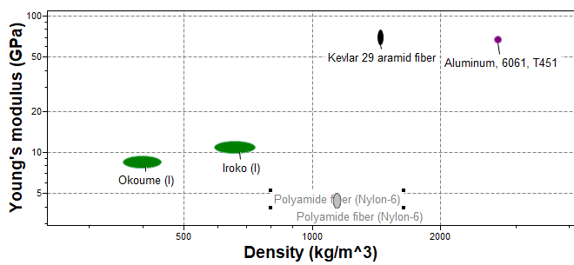**Young modulus vs Density**

We can observe from this graph that kelvar has a high Young modulus and Density as compare to aluminium, iroko, okoume and PARA(60% glass fiber)

* **Toughness vs Density**

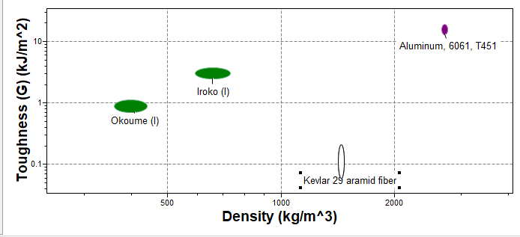

We can observe from this graph that kelvar has a high Toughness as compare to aluminium, iroko, okoume and PARA(60% glass fiber)

* **Hardness Vickers vs Density**

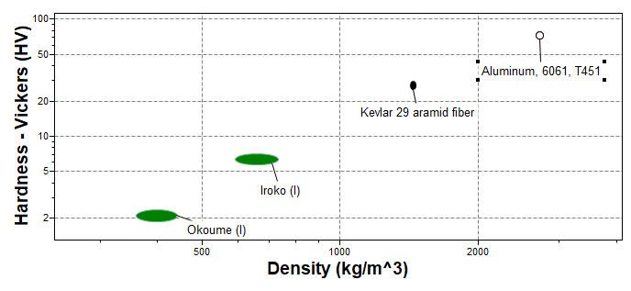

We can observe from this graph that kelvar is harder as compare to aluminium, iroko, okoume and PARA(60% glass fiber)

* **Water (fresh) vs density**

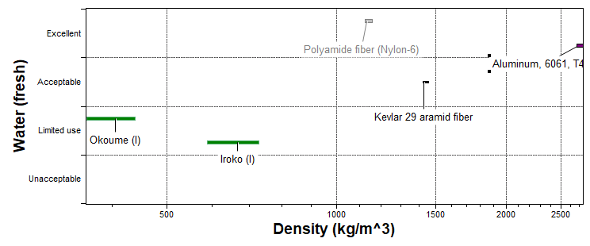

We can observe from this graph that PARA(60% glass fiber) is more resistant into frsh water as compare to aluminium, kelvar, okume and iroko

**Price vs density**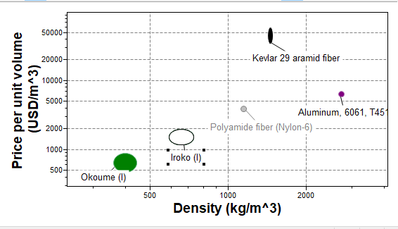

Okoume is less expensive as compare to iroko, aluminum, PARA(60% glass fiber) and kelvar

**Process associated with the material selected to manufacture the hull of the boat**

**I. Industrial processes for each material**

1. **Aluminum 6061, T451**

The process of making the hull of the boat with 6061 aluminum is done by welding

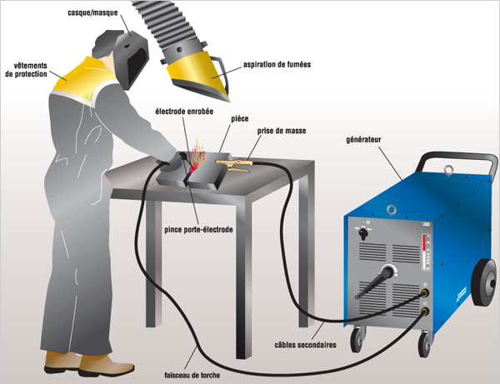

Here are some possible manufacturing processes for the hull of a 6061-T451 aluminum boat:

*Arc welding:* This process uses an electric arc to melt the metal and create a weld. It is relatively simple to learn and can be used to weld thick aluminum sheets.

*TIG welding:* This process uses an electric arc and an inert gas to protect the weld from oxidation. It produces high-quality welds, but it is more difficult to learn than arc welding.

*MIG welding:* This process uses an electric arc and continuous welding wire to create a weld. It is faster than TIG welding, but it produces slightly lower quality welds.

*Brazing:* This process uses a filler metal with a lower melting point than aluminum to create a weld. It is often used to join small parts or to repair cracks.

The choice of manufacturing process for a 6061-T451 aluminum boat hull depends on several factors, including:

Hull size and complexity: For small, simple hulls, arc welding may be a viable option. For larger, more complex hulls, TIG or MIG welding may be necessary.

Budget: Arc welding is generally the least expensive option, while TIG or MIG welding can be more expensive.

The Expertise: Arc welding is a relatively simple process that can be learned by most qualified welders. TIG and MIG welding require a higher level of expertise.

NB: After welding, it may be necessary to heat treat the shell to improve its mechanical properties.

**b) PARA (60% glass fiber)**

The manufacture of a PARA boat hull is done by contact molding:

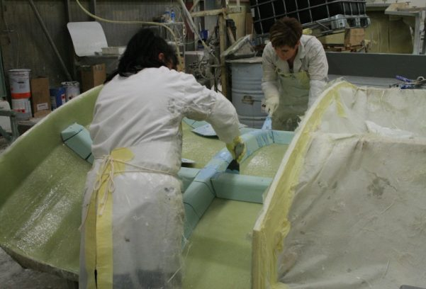

**1. Preparing the mold:**

* Choose a negative mold of the desired shape for the shell. The mold can be made of wood, fiberglass or metal.
* Apply a release agent to the mold to facilitate the release of the shell.

**2. Preparation of the PARA:**

* Cut the PARA into strips or sheets of the desired size.
* Mix the resin and hardener

**3. Lamination of PARA:**

* Apply a first layer of resin to the mold.
* Place the strips or sheets of PARA on the resin, overlapping them slightly.
* Apply a second coat of resin to the PARA, making sure to fully impregnate all fibers.
* Repeat the operation adding layers of PARA and resin until the desired thickness of the hull.

**4. Hardening:**

* Allow the resin to cure completely according to the manufacturer's instructions. Curing time may vary depending on temperature and amount of hardener used.

**5. Unmolding:**

* Once the resin has hardened, unmold the shell from the mold.
* Sand and smooth the hull surface if necessary.

**6. Finishing:**

* Apply a layer of gelcoat to protect the hull from UV and bad weather.
* Paint the hull according to the desired color.

**c) Kelvar 29 aramid fiber**

Possible processes for manufacturing the hull of a Kevlar 29 boat:

**1. Contact molding:**

Principle : Kevlar 29 is applied to a negative mold, then laminated with resin and hardener.

Advantages: Simple and inexpensive process, suitable for simple shapes.

Disadvantages: Less smooth finish, risk of air bubbles, less resistant than other processes.

**2. Vacuum infusion:**

Principle: Kevlar 29 is placed in a vacuum mold, then the resin and hardener are injected under pressure.

Advantages: Smooth finish, absence of air bubbles, better mechanical resistance.

Disadvantages : More complex and expensive process, requires specific equipment.

**3. RTM (Resin Transfer Molding)** :

Principle: Kevlar 29 is placed in a closed mold, then the resin and hardener are injected under pressure.

Advantages: Smooth finish, absence of air bubbles, good mechanical resistance, mass production possible.

Disadvantages: Complex and expensive process, requires a specific mold.

**4. Pultrusion:**

Principle: Kevlar 29 is impregnated with resin and hardener, then pulled through a die to obtain a continuous profile.

Advantages: Fast and automated production, good mechanical resistance.

Disadvantages: Limited to simple shapes, requires specific equipment.

**D) OKOUME COUNTERPLATE**

1. **Lamination by veneer:**

This process involves the use of thin sheets of okoume plywood that are glued and laminated together to form the shell. Plywood sheets are typically arranged in cross layers to improve strength and structural stability. Okoume veneer is glued with a water-resistant marine adhesive and pressed to form a strong structure.

**2. Vacuum molding:**

In this process, sheets of okoume plywood are placed on a shell-shaped mold. A vacuum bag is then used to apply even pressure to the plywood, forcing it to conform to the shape of the mold. Adhesive is applied between layers of plywood to glue them together. This process makes it possible to obtain light and resistant hulls.

**3. Resin infusion casting:**

This process uses a shell-shaped mold and a resin infusion technique to make the okoume shell. Layers of okoume plywood are placed in the mold, and an epoxy or polyester resin is then infused through the plywood layers using a vacuum pump. This process makes it possible to obtain a light, strong shell without air bubbles.

**Strip-planking construction:**

This process involves joining together narrow strips of okoume plywood, called slats, to form the shell. The slats are glued to each other and reinforced with fiberglass and resin. This creates a strong, lightweight structure, ideal for small boats.

**E) Iroko**

Possible processes for manufacturing the hull of an Iroko boat:

**1. Lap construction:**

Principle: The Iroko is cut into planks which are assembled edge to edge to form the hull. The boards are fixed together with nails or screws.

Advantages: Traditional and aesthetic process, suitable for simple shapes.

Disadvantages: Heavy hull, risk of leaks, requires regular maintenance.

**2. Freeboard construction:**

Principle: The Iroko is cut into planks which are assembled vertically to form the hull. The boards are fixed together with bolts or rivets.

Advantages: Stronger shell than lap construction, less susceptible to leaks.

Disadvantages: Heavy hull, requires regular maintenance.

**3. Plywood construction:**

Principle: Iroko is used for veneering marine plywood. The plywood is then cut and assembled with water-resistant glue (epoxy) to form the hull.

Advantages: Lighter hull than lap or freeboard construction, less susceptible to leaks.

Disadvantages: Requires high quality marine plywood, risk of delamination.

**Etude comparative des différents procede de fabrication de chaque matériau**

1. **Aluminium 6061, T451 :**

| **Process** | **Price** | **Advantages** | **Disadvantages** | **Feasibility** | **Environmental Impact** | **Suitable for a Racing Boat** |
| --- | --- | --- | --- | --- | --- | --- |

|  |  |  |  |  |  |  |
| --- | --- | --- | --- | --- | --- | --- |
| **Process** | **Price** | **Advantages** | **Disadvantages** | **Feasibility** | **Environmental Impact** | **Suitable for a Racing Boat** |
| **Arc Welding** | **Low** | Easy to learn, suitable for thick sheets | Less resistant welds, risk of porosity | Easy | Emissions of fumes and gases | Not recommended |
| **TIG Welding** | **Medium** | High-quality welds, low risk of porosity | More difficult to learn, slower | Medium | Emissions of inert gases | Recommended |
| **MIG Welding** | **Medium** | Faster than TIG, suitable for thin sheets | Lower quality welds, risk of porosity | Medium | Emissions of gases and fumes | Acceptable |
| **Brazing** | **Low** | Suitable for small parts, crack repair | Less resistant welds, not suitable for major structures | Easy | Emissions of fumes and gases | Not recommended |

**Explanation of the Table:**

* **Price:** Arc welding is the most affordable, followed by MIG welding and TIG welding. Brazing is also inexpensive.
* **Advantages:** TIG welding offers the best weld quality, while arc welding is the easiest to learn. MIG welding is fast, and brazing is useful for small repairs.
* **Disadvantages:** Arc welding and MIG welding can produce less resistant welds and are more prone to porosity. TIG welding is slower and more difficult to master. Brazing is not suitable for major structures and offers limited strength.
* **Feasibility:** Arc welding is the easiest to learn, followed by MIG welding and TIG welding. Brazing is also easy to use.
* **Environmental Impact:** All welding processes produce emissions of fumes and gases. TIG welding uses inert gases, which have a lower environmental impact than the gases used in arc welding and MIG welding.
* **Suitable for a Racing Boat:** TIG welding is the best choice for a racing boat because it produces high-quality, strong welds, which are essential for the safety and performance of the boat. MIG welding can be acceptable, but it is important to choose appropriate welding parameters to ensure the quality of the welds. Arc welding and brazing are not recommended for major structures of a racing boat

<https://www.aws.org/>

<https://www.sailing.org/>

<https://www.aluminum.org/>

1. **PARA (60% glass fiber) et Kelvar 29 aramid fiber :**

|  |  |  |  |  |  |  |
| --- | --- | --- | --- | --- | --- | --- |
| **Process** | **Price** | **Advantages** | **Disadvantages** | **Feasibility** | **Environmental Impact** | **Suitable for a Racing Boat** |
| **Contact Molding** | **Low** | Simple and inexpensive, suitable for simple shapes | Less smooth finish, risk of air bubbles, less resistant than other processes | Easy | Moderate emissions of volatile organic compounds (VOCs) | Not recommended |
| **Vacuum Infusion** | **Medium** | Smooth finish, no air bubbles, better mechanical strength | More complex and expensive, requires specific equipment | Medium | Moderate emissions of VOCs | Recommended |
| **RTM (Resin Transfer Molding)** | **High** | Smooth finish, no air bubbles, good mechanical strength, mass production possible | Complex and expensive, requires a specific mold0 | Difficult | Moderate emissions of VOCs | Recommended |
| **Pultrusion** | **Medium** | Fast and automated production, good mechanical strength | Limited to simple shapes, requires specific equipment | Medium | Moderate emissions of VOCs | Not recommended |

**Explanation of the Table:**

* **Price:** Contact molding is the most affordable, followed by pultrusion and vacuum infusion. RTM is the most expensive.
* **Advantages:** Vacuum infusion and RTM offer the best finish quality and mechanical strength. Contact molding is simple and inexpensive. Pultrusion is fast and automated.
* **Disadvantages:** Contact molding has a risk of air bubbles and lower strength. Vacuum infusion and RTM require specific equipment and are more complex. Pultrusion is limited to simple shapes.
* **Feasibility:** Contact molding is the easiest to implement, followed by pultrusion and vacuum infusion. RTM is the most difficult.
* **Environmental Impact:** All PARA manufacturing processes produce emissions of volatile organic compounds (VOCs). The environmental impact is moderate for all processes.
* **Suitable for a Racing Boat:** Vacuum infusion, is the best choice for a racing boat because it produce high-quality, strong structures, essential for the safety and performance of the boat. Contact molding is also be recommended as alternative for major structures of a racing boat. Pultrusion is limited to simple shapes and is not suitable for manufacturing a complete hull.

[https://www.dupont.com/products-and-services/fabrics-films-and-nonwovens](https://www.dupont.com/products-and-services/fabrics-films-and-nonwovens/kevlar.html)

<https://www.compositesworld.com/>

1. **Iroko et okoume :**

|  |  |  |  |  |  |  |
| --- | --- | --- | --- | --- | --- | --- |
| **Method** | **Price** | **Advantages** | **Disadvantages** | **Feasibility** | **Environmental Impact** | **Suitable for a Racing Boat** |
| **Clinker Construction** | **Low** | Traditional and aesthetic process, suitable for simple shapes | Heavy hull, risk of leaks, requires regular maintenance | Easy | Low | **Clinker Construction** |
| **Carvel Construction** | **Medium** | Stronger hull than clinker construction, less prone to leaks | Heavy hull, requires regular maintenance | Medium | Low | **Carvel Construction** |
| **Plywood Construction** | **Medium** | Lighter hull than clinker or carvel construction, less prone to leaks | Requires high-quality marine plywood, risk of delamination | Medium | Low | Recommended |
| **Strip-planking Construction** | **High** | Light and strong hull, aesthetic | Complex and time-consuming process, requires expertise and specific equipment | Difficult | Low | **Strip-planking Construction** |

**Explanation of the Table:**

* **Price:** Clinker construction is the most affordable, followed by carvel construction and plywood construction. Strip-planking construction is the most expensive.
* **Advantages:** Strip-planking construction offers the best finish quality and mechanical strength. Plywood construction is light and resistant to leaks. Clinker construction is traditional and aesthetic. Carvel construction is stronger than clinker construction.
* **Disadvantages:** Clinker and carvel construction are heavy and prone to leaks. Plywood construction requires high-quality marine plywood and is susceptible to delamination. Strip-planking construction is complex and time-consuming to build.
* **Feasibility:** Clinker construction is the easiest to implement, followed by carvel construction and plywood construction. Strip-planking construction is the most difficult.
* **Environmental Impact:** All iroko construction methods have a low environmental impact.
* **Suitable for a Racing Boat:** Strip-planking construction and plywood construction are the best choices for a small racing boat because they offer a light and strong hull, essential for the performance and handling of the boat. Clinker and carvel construction are too heavy and are not recommended for a racing boat.

**Conclusion:**

For the construction of a small racing boat made from iroko, strip-planking construction or plywood construction are the most suitable methods. They offer an excellent compromise between lightness, strength, and performance. Strip-planking construction is the best option for a high-performance racing boat, but it is more complex and expensive. Plywood construction is a more affordable and easier-to-implement alternative.

<https://www.boatdesign.net/forums/>

<https://www.boatbuilders.org/>

<https://www.woodenboat.com/>

<https://www.boatdesign.net/forums/threads/clinker-construction.47166/>

1. **Procédé présent au fablab de chaque matériau**

Le matériau qui peut être utilise au fablab de l’UCAC-ICAM pour la production de la coque du bateau est le bois et dans notre cas c’est l’iroko qui est le bois choisis. Et le procédé de fabrication de la coque utiliser ici est la construction en contre-plaqué avec l’utilisation des fraises.

Fabrication de la coque d'un bateau en iroko par contre-plaqué avec fraise :

**1. Préparation :**

Choisir le contre-plaqué: Utiliser un contre-plaqué marin de haute qualité, adapté à la construction de bateaux. L'épaisseur du contre-plaqué dépendra de la taille et de l'usage du bateau.

Découper les panneaux: Découper les panneaux de contre-plaqué à la forme et aux dimensions souhaitées pour la coque, en utilisant une fraise à défoncer ou une scie circulaire.

Façonnage des joints: Façonner les joints entre les panneaux de contre-plaqué, en utilisant une fraise.

Perçage des trous: Percer les trous pour les vis ou les rivets, en utilisant une fraise à forer.

**2. Assemblage :**

Assembler les panneaux: Assembler les panneaux de contre-plaqué en utilisant de la colle époxy et des vis ou des rivets.

Renforcer les joints: Renforcer les joints entre les panneaux en utilisant des bandes de fibre de verre ou de carbone, imprégnées de résine époxy.

Façonnage de la coque: Façonner la coque en utilisant une fraise à profiler ou une ponceuse.

**3. Finition :**

Appliquer un enduit: Appliquer un enduit sur la coque pour lisser les surfaces et combler les imperfections.

Poncer la coque: Poncer la coque pour obtenir une surface lisse et uniforme.

Appliquer une peinture ou un vernis: Appliquer une peinture ou un vernis pour protéger la coque contre les UV et les intempéries.

**5. Avantages de la construction contre-plaqué avec fraise :**

* Coque légère et solide.

* Procédé relativement simple et rapide.

* Bonne résistance à l'humidité et aux insectes.

* Finition esthétique.

**6. Inconvénients de la construction contre-plaqué avec fraise :**

* Nécessite un contre-plaqué marin de haute qualité.

* Risque de délaminage si la colle époxy n'est pas appliquée correctement.

* Nécessite une fraise et des outils de coupe spécifiques.

**Choice of material for the boat hull**

**Choice matrice**

|  |  |  |  |  |  |  |  |  |  |  |  |  |  |  |
| --- | --- | --- | --- | --- | --- | --- | --- | --- | --- | --- | --- | --- | --- | --- |
|  | |  | |  | |  |  |  |  |  |  |  |  |  |
| MATRICE MULTICRITERE | | | | | | | | | | | | |  |  |
| Critères | | Coef | | Aluminium 6061, T451 | | | PARA (60% fibre de verre) | | Kelvar 29 aramide | | Iroko | | Okuome | |
| Valeurs | |  | Valeur |  | Valeur |  | Valeur |  | Valeur |  |
| Résistance à l'eau | | 5 | | 4 | | 20 | 5 | 25 | 4 | 20 | 3 | 15 | 2 | 10 |
| Coût (abordable) | | 4 | | 2 | | 8 | 2 | 8 | 1 | 4 | 4 | 16 | 5 | 20 |
| Rigidité | | 3 | | 4 | | 12 | 3 | 9 | 5 | 15 | 2 | 6 | 1 | 3 |
| Densité | | 3 | | 2 | | 6 | 2 | 6 | 1 | 3 | 4 | 12 | 5 | 15 |
| Dureté | | 2 | | 3 | | 6 | 2 | 4 | 4 | 8 | 3 | 6 | 2 | 4 |
| Module de Young | | 1 | | 4 | | 4 | 2 | 2 | 4 | 4 | 2 | 2 | 2 | 2 |
| Disponibilité (Cameroun) | | 3 | | 3 | | 9 | 2 | 6 | 1 | 3 | 5 | 15 | 5 | 15 |
| Résistance aux chocs | | 2 | | 2 | | 4 | 3 | 6 | 4 | 8 | 2 | 4 | 1 | 2 |
| ACV | | 2 | | 2 | | 4 | 3 | 6 | 1 | 2 | 4 | 8 | 4 | 8 |
| TOTAL | | | | 73 | | | 72 | | 67 | | 84 | | 79 | |
|
| Okoumé | | | |
| Valeur | |  | |
| 2 | | 10 | |
| 5 | | 20 | |
| 1 | | 3 | |
| 5 | | 15 | |
| 2 | | 4 | |
| 2 | | 2 | |
| 5 | | 15 | |
| 1 | | 2 | |
| 4 | | 8 | |
| 79 | | | |
|